**BIRLA INSTITUTE OF TECHNOLOGY & SCIENCE, PILANI**

**First Semester, 2020-21**

**MATH F444, Numerical Solutions to Ordinary Differential Equations**

**Assignment 2 Date: 17/11/2020**

**Name: Salmaan Shahid ID no: 2016B4A70580P**

**______________________________________________________________________________**

Gas flows through micro/nano scale channels find their applications in broad areas of science, engineering and bio-medical sciences. We consider processes that fall into the class of steady shear flows, mainly steady Poiseuille flows [[M. Torrilhon and H. Struchtrup](https://doi.org/10.1016/j.jcp.2007.10.006)].

Let us consider shear flow which is homogeneous in $z-$ direction and for the velocity we assume that $v_{y}=v_{z}=0,$ thus the velocity vector is given by

$$V=\left[\begin{matrix}v_{x}\left(y\right), & 0 & 0\end{matrix}\right].$$

The flow is driven by a body force (gravity or a pressure gradient) acting only in $x-$ direction,

$$f=\left[\begin{matrix}F, & 0 & 0\end{matrix}\right].$$

This setting is valid for channel flows as displayed in Fig. 1. The fluid (ideal gas) is confined between two infinite plates at distance $L$ and is moving solely in $x-$ direction.

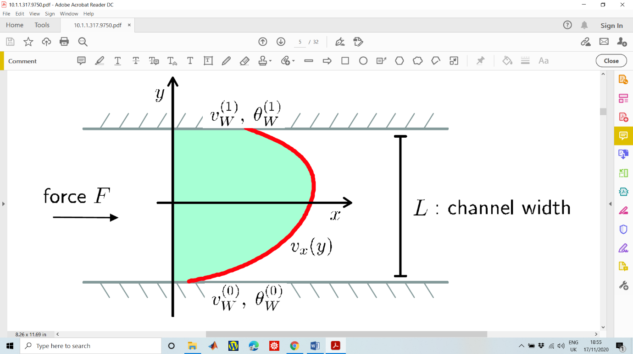

Fig. 1: General shear flow setting. The gas flows between infinite plates with velocities $v_{w}^{(0,1)}=0$ and temperature ${ θ}_{w}^{(0,1)}=1$. The force $F$ is given by gravity or a pressure gradient.

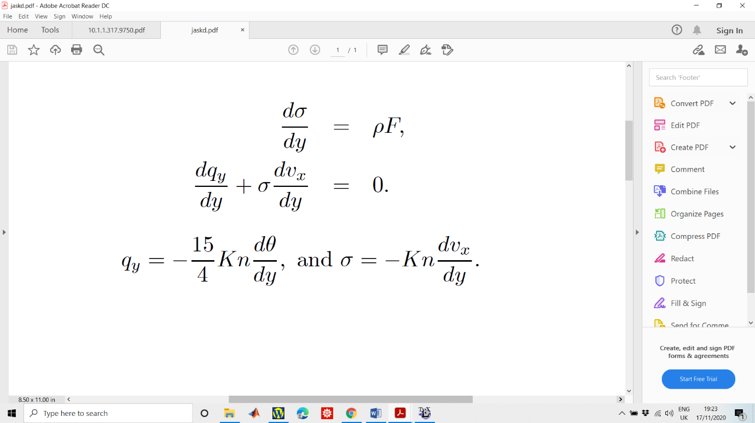The differential equations, describing this process are given by the conservation laws:

Here*, $v_{x}\left(y\right)$*  is the velocity of the gas in x-direction, $ρ\left(y\right)$ is gas density, which is given by the ideal gas law $ρ\left(y\right)={p_{0}}/{θ\left(y\right)}$, where $p_{0}=1$ is the dimensionless pressure (a constant) in the gas across the channel and $θ\left(y\right)$ is the dimensional temperature of the gas.

The heat flux in $y-$ direction $q_{y}\left(y\right)$ and the shear stress $σ\left(y\right)$ are given by the Fourier’s law and the Navier-Stokes relations, respectively as



Here, $Kn$ is defined as the Knudsen number, a parameter which dictates the degree of rarefaction in the gas.

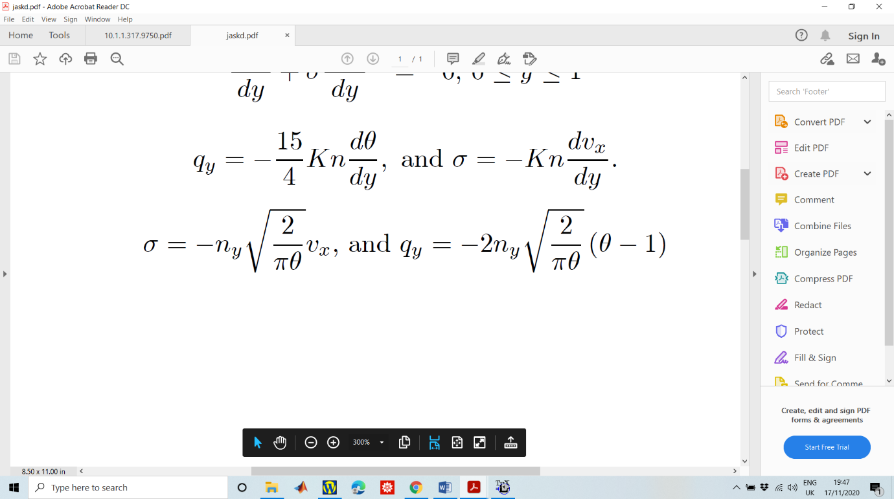This system of four ODEs needs to be solved for four unknowns ($v_{x}\left(y\right), σ\left(y\right), θ\left(y\right), q_{y}\left(y\right)$) $; 0≤y≤1$. The required boundary conditions for such systems are given by the velocity-slip and temperature-jump boundary conditions, as

Where following the setting of Fig.1 these boundary conditions have to hold on both sides of the channel with $n_{y}= ±1$ for lower ($y=0$) and upper wall ($y=1$), respectively.

Our task is to use the **mid-point finite difference method** in order to solve the above system of BVPs with $F=0.23$, and with Knudsen number $Kn=0.068, 0.1, 0.5$ along with discretized points $N = 200$.

**Part 1**

(a) Plot velocity $v_{x}$ vs $y$ for $Kn=0.068, 0.1, 0.5$ in the same plot.

(b) Plot velocity $σ$ vs $y$ for $Kn=0.068, 0.1, 0.5$ in the same plot.

(c) Plot velocity $θ$ vs $y$ for $Kn=0.068, 0.1, 0.5$ in the same plot.

(d) Plot velocity $q_{y}$ vs $y$ for $Kn=0.068, 0.1, 0.5$ in the same plot.

**INSERT FIGURE A HERE**

**INSERT FIGURE B HERE**

**INSERT FIGURE C HERE**

**INSERT FIGURE D HERE**

**Part 2**

Perform an empirical error of convergence (EOC) analysis of the numerical method in velocity, with $Kn=0.068 and 0.5.$

**INSERT FIGURE EOC HERE**

**Kn = 0.068, Slope of best fit line = 2.0304**

**Kn = 0.5, Slope of best fit line = 2.0292**

How the EOC is affected by the Knudsen number?

**Ans:** Larger Knudsen number (i.e. $Kn = 0.5$) shows smaller error in $v_{x}\left(y\right)$. This might be because $\frac{dv_{x}\left(y\right)}{dy}= -\frac{σ}{Kn}$ and as $Kn$ increases, $\frac{dv_{x}\left(y\right)}{dy}$ tends to 0 i.e. $v_{x}(y)$ tends towards being a constant. This maybe the reason why error decreases. For both $Kn=0.068$ and $Kn=0.5$, the method is 2nd order as we can see from the slope of the best fit line which is $2.03$ in case of $Kn=0.068$ and $2.03$ in case of $Kn=0.5$. This can be seen from **Figure A** in part **A.** There is no change in order of the method as $Kn$ changes.